**Name: Harshavardhana K**

**USN: 1BM18CS035**

**Program Number :**

**Program Title : Vibrating motor.**

**AIM: Motor starts vibrating whenever light is detected.**

**Hardware Required:**

* **Arduino Board**
* **Vibrating motor**
* **NPN transistor**
* **Photo resistor**
* **Multi meter**

**Circuit Diagram:**

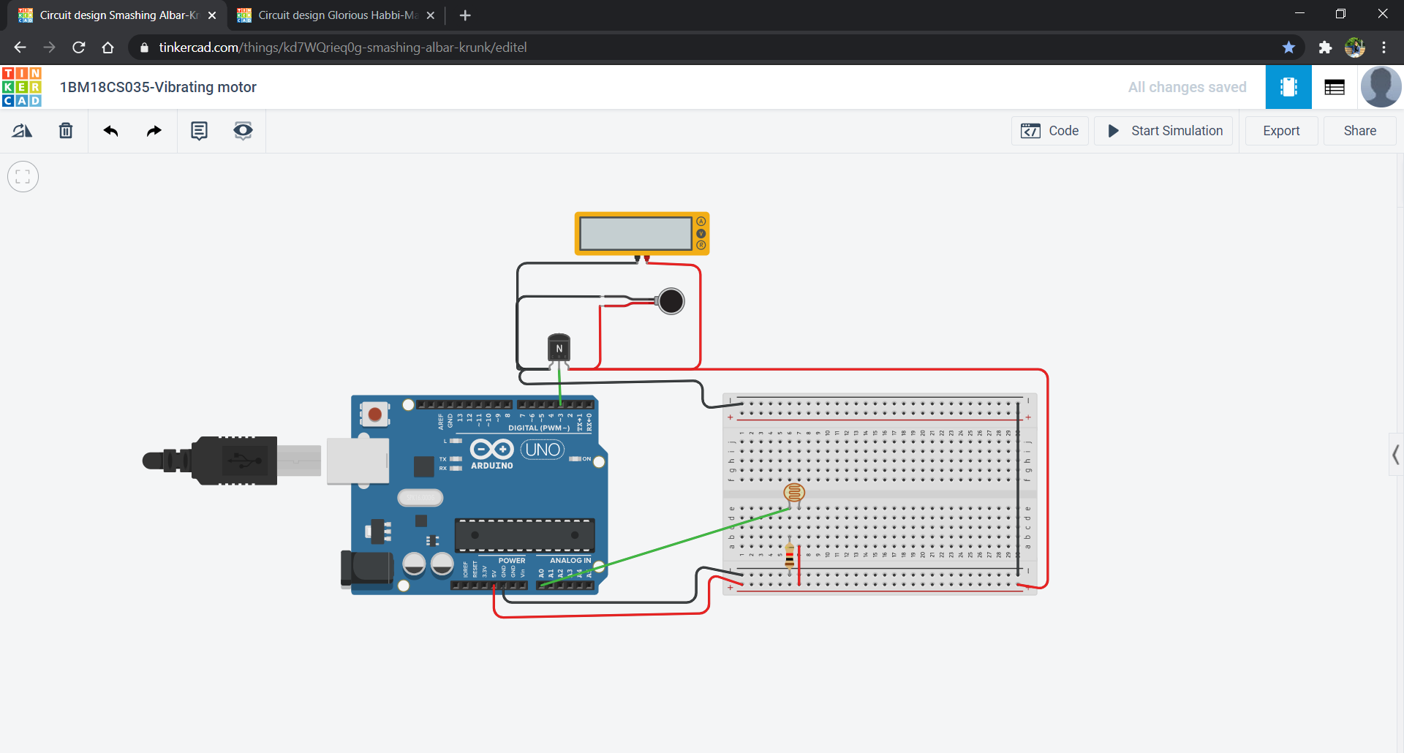

**Circuit diagram along with code:**

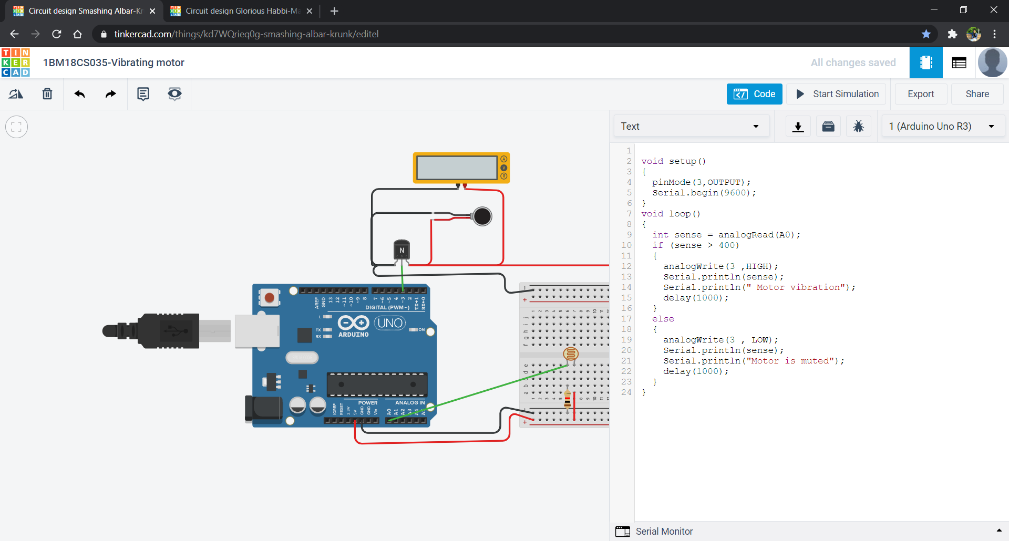

**Simulation:**

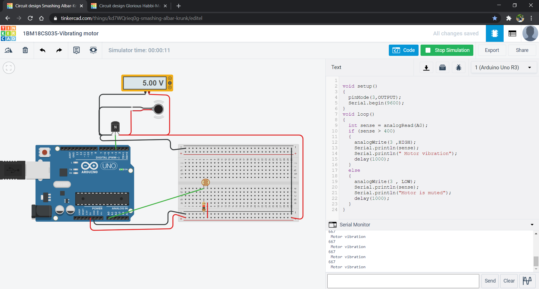

**Code:**

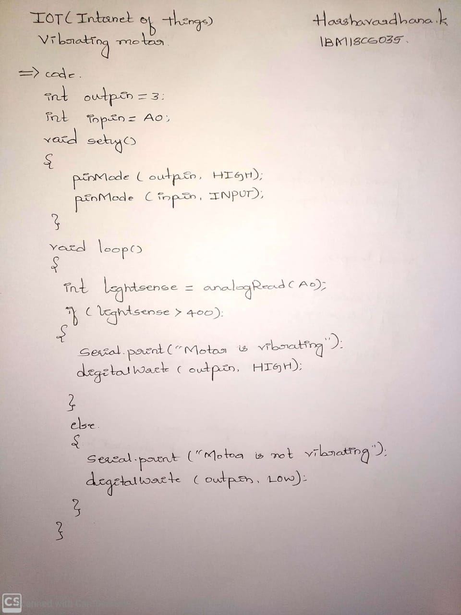

**Observation/output:**

Motor starts to vibrate in presence of light.